TeslaTouch: Electrovibration for Touch Surfaces

【Summary】：We present a new technology for enhancing touch inter-faces with tactile feedback. The proposed technology is based on the electrovibration principle, does not use any moving parts and provides a wide range of tactile feedback sensations to fingers moving across a touch surface. When combined with an interactive display and touch input, it enables the design of a wide variety of interfaces that allow the user to feel virtual elements through touch.

【feature】：

Tactile feedback based on electrovibration has several compelling properties. It is fast, low-powered, dynamic, and can be used in a wide range of interaction scenarios and applica-tions, including multitouch interfaces.

【contribute】：

1. We present the principles and implementation of electrovibration-based tactile feedback for touch surfaces.
2. We report the results of three controlled psychophysical experiments and a sub-jective user evaluation, which describe and characterize users’ perception of this technology.
3. We analyze and compare our design to traditional mechanical vibrotactile displays and highlight their relative advantages and disad-vantages.
4. We explore the interaction design space.

【TeslaTouch】：

**Tactile feedback apparatus**

We used a 3M Microtouch panel [1] originally designed for capacitive­based  touch  sensing.  It  is  composed  of  a  trans­parent electrode sheet applied onto a glass plate coated with an insulator layer (Figure 2).

**Grounding strategies**

**Safety**

**Instrumenting touch surface**

We  chose  to  implement  a  TeslaTouch tactile display for multitouch interactive table­top surfaces [24] (Figure 3). The capacitive touch panel was used  as  a  projection  and  input  surface.  An  additional  dif­fuser plane was installed behind the panel; a projector was used to render graphical content. To capture the user input, the panel was illuminated from behind with infrared illumi­nators. An infrared camera captured reflections of user fin­gers touching the surface.

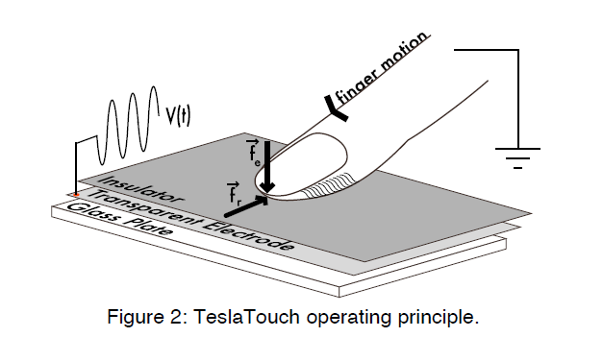 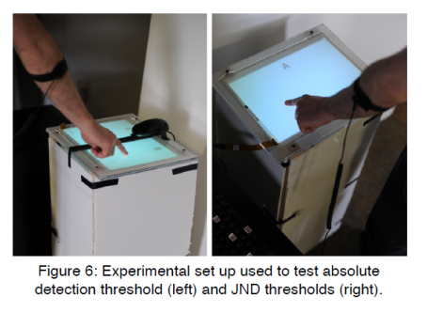

【User Study】:

**Subjective Evaluation of TeslaTouch:**

To better understand how us-ers interpret the tactile sensations produced by TeslaTouch.

Procedure:

For each texture, participants filled out a three-section ques-tionnaire. The first section asked participants to describe each sensation in their own words. The second section in-troduced 11 nouns (e.g., fur, silk, jeans, sand paper, skin) and asked participants to select nouns that described the tactile sensations as closely as possible. In the final section, participants rated different dimensions of sensations on a five-point Likert scale (e.g. from smooth to sticky).

Results:

As we expected, low frequency stimuli were perceived as rougher compared to high frequencies. They were often likened to “wood” and “bumpy leather”, versus “paper” and “a painted wall” for higher frequency stimuli.

When describing tactile sensations produced by Tesla-Touch, participants often described them as a combination of vibration and friction sensations. High frequency stimuli were rated as more related to friction than low frequency stimuli, which were related more to vibration (mean ratings of 2.9 and 3.6 respectively). However, this effect was not statistically significant. This seeming duality of tactile sen-sation elicited by TeslaTouch is an interesting direction for future experimentation.

**Psychophysics of TeslaTouch:**

In this section, we investigate perception-based characteris-tics of electrovibration. These include absolute detection thresholds and frequency and amplitude discrimination thresholds.

Procedure:

All participants completed detection threshold experiments before discrimination threshold experiments. In the absolute detection threshold experiments, participants were pre-sented with two equally sized areas marked with letters A and B separated by a cardboard piece (Figure 6). Partici-pants had eight seconds to compare areas A and B and re-spond by clicking a mouse button. In discrimination thresh-olds experiments, three screens were presented one after another marked with letters A, B and C. Participants had as much time as needed to feel tactile sensations on each screen. They progressed to the next screen by pressing the spacebar and were not allowed to return to the previous screen. After finishing all three screens, participants were prompted to select one that was different from the other two by pressing marked keys on the keyboard.

Results:

*Absolute Detection Thresholds*

*Frequency Discrimination Thresholds*

*Amplitude Discrimination Thresholds*

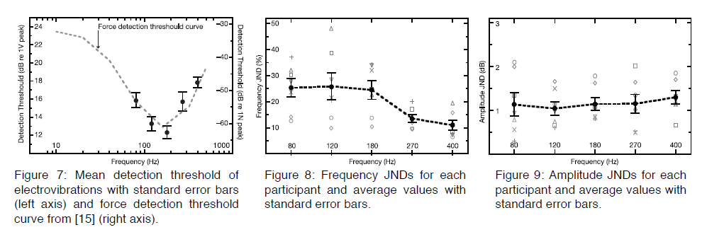

【ELECTROVIBRATION VS. MECHANICAL STIMULATION】：(detail in paper)

Compare two type of screen feedback

【Applications】：

Anchored Gestures

Two-Handed Asynchronous Manipulation

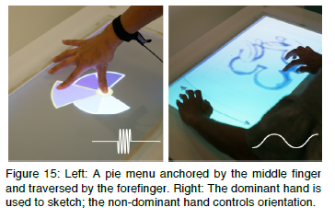

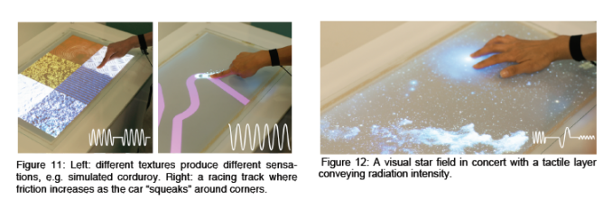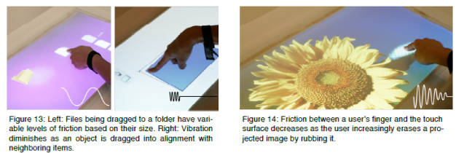

【conclusion】:

This paper introduced TeslaTouch: a new technology for tactile display based on electrovibration. This technology can be adapted to a wide range of input tracking strategies, and can be used in many applications. Four experiments were conducted to characterize users’ perception of Tesla-Touch, providing a foundation for designing effective tac-tile sensations. A comparison between mechanical actuation and electrovibration led to an overview of the TeslaTouch applications design space.